**Week 4 Quiz**



**1.) $A=\{-1,0,1,2,3,4,5\}$ $B=\{-9,-8,-7,-6,-5,-4,-3,-2,-1,0,1,2\}$ $C=\{2, 3\}$ $$\left(A-C\right)∪A=\left\{-1,0,1,4,5\right\}∪\left\{-1,0,1,2,3,4,5\right\}=\left\{-1,0,1,2,3,4,5\right\} \\ \left(A∩B\right)-C=\left\{-1,0,1,2\right\}-\left\{2,3\right\}=\{-1,0,1\} \\ B∩C^{C}=\{-9,-8,-7,-6,-5,-4,-3,-2,-1,0,1\}$$**

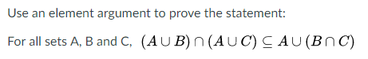

**2.) Suppose $x∈(A∪B)∩(A∪C)$. By definitions of union and intersect , $(x∈A$ or $x∈B)$ AND $(x∈A$ or $x∈C)$. This states that x is an element in sets A or B, and also x is an element in set A or C. It follows that x must be an element in A or an element in B and C.   
On the other hand, $x∈A∪(B∩C)$ implies that $x∈A$ or $(x∈B$ AND $x∈C)$. This states that x is an element in A or an element in B and C.  
Therefore, $x∈(A∪B)∩(A∪C)$ follows that $x∈A∪(B∩C)$. Hence we can conclude that $\left(A∪B\right)∩\left(A∪C\right)⊆A∪(B∩C)$ [what we needed to show.]**



**3.) $A∪\left(B-C\right)=A∪(B∩C^{C})$ by Set Difference law $=(A∪B)∩(A∪C^{C})$ 
 by Distributive law $=(A∪B)∩{(A^{c}∩C)}^{C}$ 
 by DeMorgan’s law $=(A∪B)∩{(C∩A^{C})}^{C}$ 
 by Commutative law $=(A∪B)∩{(C-A)}^{C}$ 
 by Set Difference law $=\left(A∪B\right)-(C-A)$ 
 by Set Difference law**

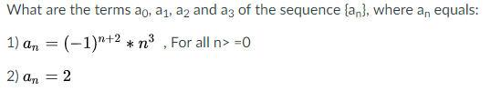

**4.) 1.) $a_{0}={\left(-1\right)}^{0+2}*0^{3}=0$ $$a_{1}={(-1)}^{1+2}*1^{3}=-1 \\ a_{2}={(-1)}^{2+2}*2^{3}=8 \\ a_{3}={(-1)}^{3+2}*3^{3}=-27$$**

**2.) $a_{0}=2$ $$a_{1}=2 \\ a_{2}=2 \\ a_{3}=2$$**

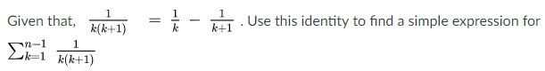

**5.) $\frac{1}{k}-\frac{1}{k+1}+\frac{1}{k+1}-\frac{1}{k+2}+…+\frac{1}{n-1}-\frac{1}{n}=\frac{1}{k}-\frac{1}{n}$**

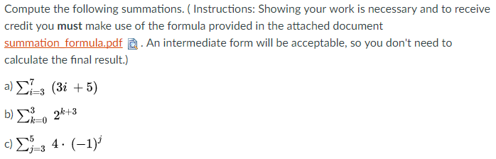

**6.a.) $\sum_{i=3}^{7}{\left(3i+5\right)=}\sum_{1}^{7}{\left(3i+5\right)-\sum_{1}^{2}{\left(3i+5\right)}}$ $$=\left(\sum_{1}^{7}{3i}+\sum_{1}^{7}{5}\right)-\left(\sum_{1}^{2}{3i}+\sum_{1}^{2}{5}\right) \\ =\left(3\sum_{1}^{7}{i}+\sum_{1}^{7}{5}\right)-\left(3\sum_{1}^{2}{i+\sum_{1}^{2}{5}}\right) \\ =\left(3⋅\frac{7\left(7+1\right)}{2}+7⋅5\right)-\left(3⋅\frac{2\left(2+1\right)}{2}+2⋅5\right)$$**

**6.b.) $\sum_{k=0}^{3}{2^{k+3}}=\sum_{k=0}^{3}{2^{k}⋅2^{3}}$ $$=8\sum_{k=0}^{3}{2^{k}} \\ =8⋅\frac{2^{3+1}-1}{2-1}$$**

**6.c.) $\sum_{j=3}^{5}{4⋅{\left(-1\right)}^{j}}=\sum_{j=0}^{5}{{4⋅\left(-1\right)}^{j}}-\sum_{j=0}^{2}{4⋅{(-1)}^{j}}$ $$=\frac{4⋅{\left(-1\right)}^{5+1}-4}{-1-1}-\frac{4⋅{\left(-1\right)}^{2+1}-4}{-1-1}$$**